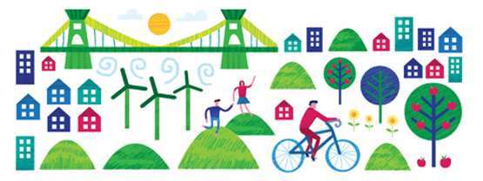

My Green City Design Challenge

Introduction
As the world’s population increases and more people live in urban areas, there are some real challenges ahead for city planners and architects. The Director of the United Nations has said that “managing urban areas has become one of the most important development challenges of the 21st century”. If we fail to build cities that are sustainable all of our futures are at risk.

Key facts
- Over 7.3 billion people live on Earth, with the population due to increase to a whopping 9.8 billion by 2050 (worldpopdata.org).
- Currently over 79 % of the UK’s population live in cities. By 2050 this number increases to 92% of the UK population who will be calling a city their home (prb.org)
- Land will be become increasingly expensive and limited in cities due to the increase in population.
- Many people are working towards trying to make cities more sustainable. A sustainable city uses resources to offer a good quality of life to the people that currently live there whilst ensuring that there are enough resources are available for future generations.
How can you build a sustainable city?
Your sustainable city must include plans to produce energy, provide inhabitants with food, handle waste efficiently, transport people and produce around the city, whilst ensuring that nature is welcomed and supported in your city.
1. Energy
People expect higher standards of living and the latest devices gobble up energy. We still use a lot of fossil fuels, like oil coal and gas. In the past 200 years we have used over two thirds of the world’s resources already and need to use more renewable energy.
How will you power your city?

2. Food
We all need to eat but in a world with more and more people, where will it all come from? Transporting food from far away is expensive and pollutes the environment. We also waste a lot of food; in the UK alone about 30 % of all food gets thrown in the bin!
How and where will you grow enough food for your inhabitants? How can you make sure you use as much of the food as possible without any waste?

3. Nature
We need to remember that humans are not the only living things on the planet and we need plants and animals to be able to survive. As you plan your city remember to include green areas in your city, and help wildlife move around your city on ‘wildlife corridors’. Wildlife Corridors are areas of planting that help the green areas in your city link up for wildlife. It may be some plants on the edge of a road, or even people’s gardens. Flowering plants help encourage pollinators in to your city; these will help your vegetables grow and increase your crop of food. It has also been proven that if people can see nature every day, and not just buildings, they are much happier and healthier.
Try and think of why you might need different plants and animals, this will help you make sure you have it in your city. How will you make sure nature is encouraged into your city?

4. Transport
The way your population moves around the city is crucial for city living. Movement in a place where so many people live and work is tricky so this needs to be carefully designed. Cars, buses, trains and trams, boats on rivers as well as walkways for pedestrians and lanes for cyclists, you need to make sure facilities are in place for the perfect balance of each. Some of the largest cities in the world have even moved their transport out of the way using underground trains and elevated monorail systems e.g. Las Vegas has motorways underneath it’s buildings.
Try to think of new ways that you could help with the infrastructure in your city. In many cities around the world the streets can become as famous as some of the buildings.
How will you help your inhabitants move around?

5. Waste
Throughout the world we dump over 2 billion tonnes of waste every year. A lot of this rubbish doesn’t rot away and finding somewhere to put all is a serious problem. We actually waste more energy by not recycling. For example: cans of drink are made from aluminium, 95% more energy is needed to make a new aluminium can compared to one made from recycling other cans.
How will you encourage people from your city to recycle more and reduce their waste?

